Disaster at the Bastion of Hajama

As the peculiars approach Halwa’s Temple of Kor, they see a huge fire burning at a distance. Thorean especially will recognize the location as the Bastion of Hajama, a fortress and a place of worship to the god Hajama. The fact that a fortress is on fire is not good news. The group can decide to investigate. (Ik hoop dat Thorean hier de leiding in neemt)

The bastion is a formidable looking fortress, with a large pile of smoke ascending its walls. There doesn’t even seem to be an attack from the outside. If anything, the fire started from the inside. The gates are closed and locked from the inside. There are footsteps leading into the mountains, on which foot the bastion rests. There is no sound apart from the roaring of a fire inside the bastion.   
There are multiple ways to enter the bastion, including breaking down the door (STR 20, adv with help), Climbing the walls (DEX 20, adv with help), Investigating for another way in, Damaging the door with spells (HP50). If investigated, they can find a small back entrance between some rocks.

Inside, they can see the central building in a blazing fire. Multiple lines of blood lead into the building. Through the roar of the blaze they can hear some cheering going on inside the building. Signs of battle is everywhere, arrows lay strewn about, splatters of blood about.

Inside is a group of 4 men, 2 formidable looking men in armor, and 2 men clothed in robes. They seem to be cheering at the fire, kicking things in it. If they decide not to engage, they need to roll a combined stealth roll. If anyone rolls 1 or 20, it auto-fails or succeeds. If fail, they hear a strange whistle behind them and they all come out drawing blades, starting initiative. If they manage to stay hidden for a while, they’ll hear a whistle after a while, making the band hurry outside, ignoring the party, and leaving. The men have a certain symbol: a golden scimitar. Thorean recognizes this as the symbol of the Brotherhood of the Everlasting. If a high perception: a golden scimitar with a brazen fire, symbol of the loyalists.

If any of them is left alive, he can provide info on why they are here, why they are destroying the bastion, what they were searching for, and, with enough charisma check, will reveal that the shadow caliph wants the dwarf.

If the party was too distracted during their desert trip, Halwa City guards will arrive on place, starting to question the party, chaining them (or attempting so) to bring them back to Halwa.

If not too distracted, the party can follow tracks leading into the mountains. The tracks wind between many crags and rocks, with many small overpasses looking over them. Some small bushes grow in between the cracks of the mountain. A stinging cold wind flows down from the mountains, accentuating the differences between the daytime and nighttime in Zakhara

At the end of the tracks is a small encampment with a couple of tents. The leader of this band is called Arafaat al-Sabet, a dangerous psychopath clad in fierce armor, with only his dark brown face and hands visible. His eyes pierce in a fiery red glow. He speaks full of himself, thinking the party is just a bunch of lucky idiots that got so far, but will now meet their end, as only he, as the bravest of everyone, is worthy of Hajama’s grace. He can provide info on why the Bastion was burned down, and why the shadow caliph wants him Thorean.

In case the party was chained and brought to Halwa:

The group is put into jail, but not for long. The jail is actually pretty okay, and doesn’t seem to be fit for hardcore criminals. There is a bed, a small barred window, and a pot to relief yourself in. The bars are a thick, clean metal. It might be that this facility is not built that long ago, and hasn’t been in use for that much. Their gear is partially confiscated: obvious swords and weapons are taken away.

If the party behaves well enough in the cells, they can hear whispers from behind one of the doors leading out. A guard will escort one of the priests of Kor: al-Nassr Khatri, who vouches for them. They have received word from the Hand of the Sky that Rhundas is safe, and the party is to thank for it. He begs them to search the Bastion of Hajama for a certain book, that was meant for the Fountain of Knowledge in Huzuz. They knew something was wrong as their messenger still had not passed the Temple of Kor.

her face only partially visible, curling hair falling down. She is wearing the most beautiful blue garments, flowing behind her. Her arms filled with golden bracelets adorned with many different gems. She introduces herself as **Orana dal-Salaam**.

She is an ethoist of Selan, goddess of beauty, and she was sent to ask you for help. Selan feels the ugliness of the Shadowfell corrupting Zakhara, and they have been seen it themselves. She prizes Luna on her beauty, and tells of Selan’s symbol of the moon, as it is the most beautiful in all of the night sky. But for now, they must go to the mountains and retrieve something that was meant for the Fountain of Knowledge in Huzuz: a certain book, found by the ethoists of Hajama, and stolen.

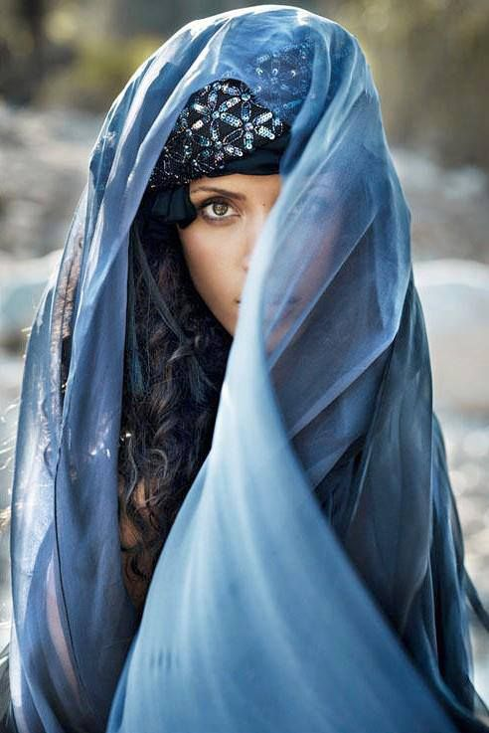

The book of Velsharoon contains the next quote: When shadows grasp is no more, and her claims to the sands have faltered, find Death’s Embrace in Dweomerheart.

The loyalists are the most dangerous group of the Holy Slayer group: the Everlasting. While they usually work around the Free Cities, the Loyalists carry out orders of the Shadow Caliph outside their territory. The current Shadow Caliph Batina Al-shaat is the new Grandfather of the Loyalists. He used to be a friend of Thorion, and now seeks him out for his betrayal at Qudra.

The tracks wind between many crags and rocks, with many small overpasses looking over them. Some small bushes grow in between the cracks of the mountain. A stinging cold wind flows down from the mountains, accentuating the differences between the daytime and nighttime in Zakhara.

The hostage will try multiple attempts to run away. At multiple moments, someone of the group will be asked to do a certain check. If the players lose the hostage, he will join Arafaat in combat, and Arafaat cannot be surprised in any way. The path to Arafaat will need to be tracked by one of the rangers.

After being led over the winding paths, a rustling from one of the bushed can be heard. Out jumps a small Pallas cat. It can be tamed with animal handling, and be spoken with with any speak with spell.   
I will inform that it is defending its territory and kittens. Using some animal handling and or some food will tame the cat, and it will sniff out Arafaat’s tent. It will NOT join the team, as it has a bunch of cute Pallas kittens it has to take care of, and does not want them all to be moved.

At the end of the tracks is a small encampment with a couple of tents. The leader of this band is called Arafaat al-Sabet, a mountain dwarf, and a dangerous psychopath clad in fierce armor, with only his dark brown face and hands visible. His eyes pierce in a fiery red glow. He speaks full of himself, thinking the party is just a bunch of lucky idiots that got so far, but will now meet their end, as only he, as the bravest of everyone, is worthy of Hajama’s grace, unlike any of the fools at the bastion. He can provide info on why the Bastion was burned down, and why the shadow caliph wants Thorean (Ran away at Qudra, the coward, and knows a secret, which the Caliph wants him dead for).

Outside of the tents is a dead body, with his throat slit open.

Arafaat has 2 slaves behind him, they will cast sanctuary on each other, and buff up the big boy. They can be convinced to not help Arafaat, either with a high persuasion (18+), a prayer of redemption by Thorean, or with any charming spell, and not join the battle. In combat, Arafaat looks extremely encumbered by his armor. Although it is formidable, it is very well not suited for combat.   
If the hostage got free, the slaves in the back will have already upcast their buffing spells .They cast sanctuary each other, one is casting Shield of Faith on Arafaat, the other Enhance ability (concentration for both), Aid, Healing Words and Cure Wounds when appropriate as well as Lesser Restoration. The will not cast ANY attacking spells.   
Stat block Arafaat: Blackguard, but with 25ft. The trick is to constantly move around, not letting him get in range. DO NOT COME IN RANGE.

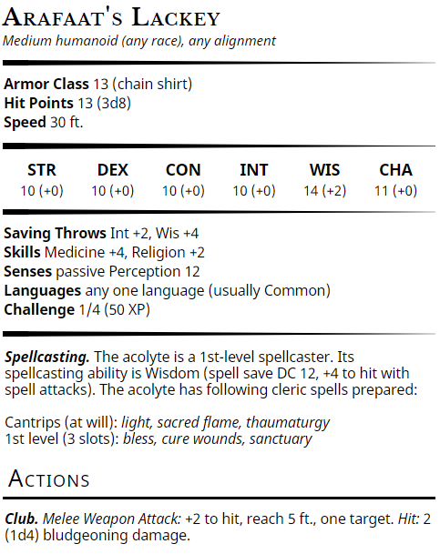 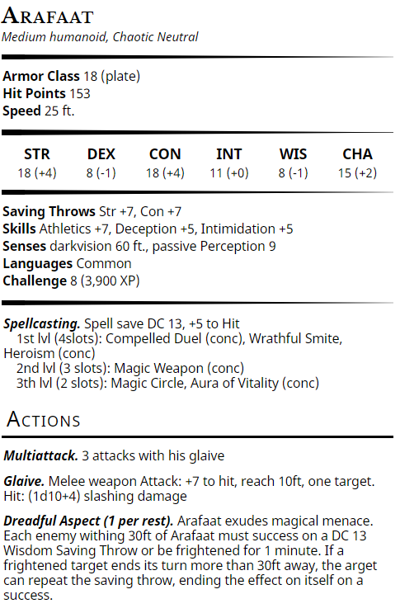

**Sanctuary:** Until the spell ends, any creature who targets the warded creature with an attack or a harmful spell must first make a Wisdom saving throw. On a failed save, the creature must choose a new target or lose the attack or spell. This spell doesn’t protect the warded creature from area effects, such as the explosion of a fireball.

**Shield of Faith**: A shimmering field appears and surrounds a creature of your choice within range, granting it a +2 bonus to AC for the duration. (Concentration)  
**Enhance Ability**: Cat's Grace: The target has advantage on [Dexterity Checks](https://roll20.net/compendium/dnd5e/Ability%20Checks#h-Dexterity%20Checks). It also doesn't take damage from [Falling](https://roll20.net/compendium/dnd5e/The%20Environment#h-Falling) 20 feet or less if it isn't [Incapacitated](https://roll20.net/compendium/dnd5e/Conditions#h-Incapacitated). (Concentration)  
**AID:** Your spell bolsters your allies with toughness and resolve. Choose up to three creatures within range. Each target's hit point maximum and current hit points increase by 5 for the duration. **CURE WOUNDS:** A creature you touch regains a number of hit points equal to 1d8 + your spellcasting ability modifier. This spell has no effect on undead or constructs. (touch)

**HEALING WORD:** A creature of your choice that you can see within range regains hit points equal to 1d4 + your spellcasting ability modifier. This spell has no effect on undead or constructs.

**AFOK and NASHAT**

He can do Wrathful smite(1), Compelled Duel on Thorion (1,Conc), Heroism (1,conc), Magic Circle on the slaves (3), Aura of Vitality (3, conc), Magic Weapon (2, conc).

Spoils from Arafaat: the Book of Velsharoon  
A pouch with the amount of gold that had been stolen from them, and an extra 100G.  
A big-ass glaive. Arafaat’s Glaive is magical, and provides +1 to attack and damage rolls.   
1D10 slashing +1, Heavy, Reach, Two-handed.   
On inspection of the glaive, it is inscribed with Midani symbols, stating ‘Blood for the Shadow Caliph’.   
The glaive’s magical properties only work when fresh blood has been applied to it within the last 24 hours. Hidden message: only on nights where the moon does not shine, or on lunar eclipses, a purple glow shines from a very small round-symbol on the glaive. The magic emboldening the glaive is necromantic, and definitely is like the magic in the shadowstuff.

Spoils from the slaves:   
2 platinum rings

The group can choose where to spend the night.

Upon returning to the temple of Kor, the ethoists will ask after the book, and if confirmed, thank the group for finding the book, and ask for it to be delivered to Huzuz.  
If they want, they can spent the night at the temple of Kor.   
The next morning, the ethoists will claim that a letter has arrived for the siblings. If asked how it got to them, they will say that the letter was slipped under their door, with no clear indications where it came from. They didn’t open it. The letter has the words ‘to my Children, Sirona and Shaya’.

It is a letter from their father.

Dearest children,

I hope your travels have been safe. Your mother and I have missed you dearly.  
Have you been eating well? Has Shaya been a good child? Have you felt the sting of the desert sun, and the bitter cold of the cloudless nights? Zakhara is a place where legends and myths are abundant, and we hope that your travels too, will be a legend told for the ages.

The town here has been still since the passing of the shadows, with nothing of worth happening. Our dear old neighbour Stephon has sadly passed away, expected given his age. A wonderful funeral was in progress and I talked at length about his good deeds, what an honest man he was, and what a loving husband and kind father he was. Finally, the widow leaned over and whispered to one of her children, "Go up there and take a look in the coffin and make sure that's your pa in there.”

Have you found any trace of the shadow being you have tracked? I look forward to what tales you can bring me from it. Have you found new friends on your travels, and made new foes? Did you find the perfect victim for your practical jokes? Did you laugh enough?

Remember, if you feel lost at any moment, take a good look, a good chuckle, and a good laugh at what’s happening, and remember that nothing is by chance, everything is connected. Stay determined, and follow the traces of the shadows, for there is never one shadow cast alone.

With great love and affection,   
Your father

It is expected that the group continues to Halwa for the information to search for the Mindflayer.   
They can do some new shopping if the group so desires.

In the city library, it is fairly hard to find any information on Mind Flayers. Here as well, are multiple scorched books and scrolls to be found. Again, ancient Midani texts are rare and damaged if found, rendered unreadable by anyone there. If asked if anyone here knows any of the languages on Kor’s letter, the gnome librarian will tell that he recognizes few of the words written on there, as it is in gnomish.

Despite the size of the library, there are no texts about the Underdark of Zakhara. Only mentions of caverns in the mountains, and a complex around the northern tip of the Vestige of Brass. There are some scrolls on Mind flayers to be found here (roll d20 on investigation, advantage if anyone else is helping, or time invested in the library. If a fifteen is rolled, they can still invest extra hours to find more info. Any roll still contains a search effort that cost an hour). For anything found here, there is more information to be found in Huzuz.   
1: A scroll pertaining to the conspiracy theory about Mind Flayers, how the current Great Caliph is a Mind Flayer, and how the Mind Flayers live underground. The way it is written feels like it does not contain any useful information.

5-10 or 1h: Psionic Commanders  
11-12 or +1h: +Hive Mind Colonies  
13-14 or +1h: + Hunger of the Mind  
15-16 or +1h: + Ceremorphosis  
17-18 or +1h: + Renegade Illithids  
19-20 or +1h: + Alhoon  
20+ or +1h: + Arcane Temptation  
Natural 20 or +1h: +Existential Fear and Dreadful Deliverance

It is also possible to find some papers about the ajami god Velsharoon, or with a religion check.  
1: Velsharoon was a jester at the court of the Grand Caliph, some 500 years ago. He died peacefully.  
5-14: or 2h: Velsharoon was a necromancer god from Faerûn.  
15-18 or +2h: Velsharoon was engulfed in the Azure Flames and died.  
19-20 or +2h: Velsharoon had a domain in Dweomerheart, part of the plane of Elysium.  
20+ or +1h: Velsharoon’s domain is called Death’s Embrace.  
natural 20 or +1h: Velsharoon had a flirtuatious relationship with Shar.

After expending X amount of time, a beautiful lady will approach those in the library. Her face only partially visible, curling hair falling down. She is wearing the most beautiful blue garments, flowing behind her. Her arms filled with golden bracelets adorned with many different gems. She introduces herself as **Orana dal-Salaam**.

She is an ethoist of Selan, goddess of beauty, and she was sent grant you help, as well as ask for help. She will ask them to gather the whole group and come to the temple of Selan in Halwa by nightfall, when the full moon shines. If the party goes to the temple earlier, then they are confronted by a closed gate, as well as many citizens of many different standings waiting. They are waiting for nightfall, for the gates to open and see the procession of the Diviner of Medina-Al-Afyal, **Bektakats Khimaksa.** They are one of the few people gifted with the power of precognition, and is deemed one of the greatest sorcerers of Zakhara, and has committed herself to Selan, the goddess of beauty.

The temple of Selan is combined into the grand palace of Halwa, in the south. A beautiful garden with small ponds leads in front of it. Palm trees rich with coconuts adorn the greens, as well as flowers of all colors, scenting the place with a pleasant rose smell. The palace itself is a grand reinforced sandstone building, with blue marbling decorating the walls and rooftiles. Large windows adorn the walls, allowing for a large amount of light to penetrate the sizeable building.

At night, the moonlight reflects on the ponds in a magical manner, refracting and lighting up the gardens as if it was lighted by bright lights. Many veiled people, from many races and statures, walk into the temple. If approached, they will tell them to gather in the hall, where they will be collected by Orana herself.

Many of the citizens have gathered in the gardens to see the beautiful procession, but only the veiled people are allowed inside, as well as our party. Inside, they are asked to give their weapons away at the armorer, and they can be recollected when leaving. This is, apart from a temple for Selan, also a diplomatic centre, and weapons are barred for everyone.

The inside of the building is lavishly decorated, with many different tapestries adorning the floors and walls. There are large cushioned benches where one can rest, some already occupied by ethoists.  
One certain figure catches your eyes, as they are being guided inside. It is a tall figure, robed in a dark-reddish dress, with the sheens and feet visible. Behind the person flows a thin cape, like a scarf in the wind, which shines with the light of the moon trickling inside. As you watch them, their face gazes towards you for a split second. Inside the headscarf you catch the glimpse of two bright white eyes on a black face, with a golden diadem over their eyebrows. Only with a perception of over 18 they can see that the face was completely featureless apart from that description.

The person is guarded by a couple of strong looking, stern genasi guards, one of each element.  
Asking around about the person will inform them that the figure is the Diviner of Selan, tasked with the heavy burden of the future.

A while after the procession of many different figures, the group is gathered by Orana. She is the lead-priestess of this temple.

*Have you enjoyed the procession? Excuse me for my short-introduction before, I, Orana, am the head-priestess of this temple. The angelic diviner of Medina -Al-Afyal has told us to gather you here, and ask your help. But first, I must tell you a story.*

*It is believed that Selan has many different incarnations. Some might know her as Selûne, as people in the north do. The compassionate Hathor or Freyja.*

*In the beginning of time, the Two-faced Godess was created out of the great nothing. They complemented each other, and brought order out of the chaos. They infused life in the heavenly bodies and this world, and bore Jisan. This universe was darkened by the hair and welcoming embrace of the Dark side, and illuminated by the cool radiant face of the light side. However, there was no fire or heat on any of the bodies. Jisan asked the the Two-Faced Goddess for warmth. It is then that the two heads were divided, being of two minds on whether they should let there be more life on the worlds or not. It is then that the Two-Faced Godess was split in twine, and they started a never-ending struggle. Out of their war came many of the different first gods, and in a moment of advantage, she reached out the universe into the plane of fire, and brought forth the fragment of ever-living flame, the sun, to give warmth to her creation, an act that has creatly angered the dark-side of Sisters-who-were-One. As the Sisters fought, their essences combined and brought forth magic as well.*

*The light side of the Two-Faced Godess is who we worship. We know her as Selan, the zenith of beauty. She has many different names, such as Selûne, which you probably already know. Others know her as Hathor, Luna, Freyja, … Many different names, but all know of her compassion. But as the moon shines bright and illuminates everything it touches, so does the moon have its dark side.*

*The twin of Selan, a goddess ajami to us, but one you have already met: Shar. Ever since the Azure flames, we, the ethoists have felt her dark influence growing in our lands, in many different forms. And now, Bektakats has foreseen your role in all this. And your first task lies in finding the creature which has been haunting you.*

*But first, I must talk to one of you. She who claims to be a daughter of the moon. Come along.*

Orana leads Luna into one of the hallways. The rest is asked to stay in the reception hall of the palace. If anyone wants to follow, Orana will say that is a private matter.

Luna is led to some kind of round oratorium. Near the walls many ethoists in beautiful garments, handsome faces, pretty hairs are seated on stone benches, they all look eagerly at Orana and what she has to say.

*Please, my beautiful friend, tell these people who you are*

It’s expected that Luna will tell about herself to them. If she tries to lie, Orana will call her out, immediately exclaiming ‘*Lie!’* .

Orana will calmly speak to Luna, in a comforting manner. However, at any point if she is interrupted, she will sternly say, “Speaking is silver, Silence is Gold, Luna”

*Now, you are in front of us, worshippers of beauty. We can simply see the shining light of the moon on your skin. You have come to our lands to beseech aid against the dragons. We, as followers of the moon, and all that is beautiful, could grant you this help. Beauty is found in all aspects of the great gods of Zakhara, and our words are influential in all regions.*

Orana leans in close, as to whisper in Luna’s ear: ‘*We could grant you an army, but we know of the darkness inside of you.’* Orana turns back away, and speaks angrily *‘That bitter, ugly darkness. Shar has already nested herself in you. You are not only a daughter of Selan, or Freyja, you are also a daughter of Shar. Their struggles continue inside of you. And we can see that Shar is getting the upper hand in you, acting out foul deeds.’* Orana turns to the spectators, raising her arms to get reactions

Some of the spectators start exclaiming:

A small figure yells: *Pride: She finds herself superior to other races, calling us pets!*  
An older figure yells: *Abusing Lust and her body for mere simple coins!*  
A fair woman yells: *Greed! Her absolute need for money endangers not only her, but her companions as well!*   
Vanity: *Vain as a peacock! Floundering about her beauty, thinking she is as a goddess!  
Mercilesness! She cut of the ear of a hostage, for no reason!* Some of the spectators gasp at the atrociousness of your deed.

Orana turns back Luna. *‘We know of your dark deeds. And now it is up to you, Luna. Will you continue on your track towards Shar, or will you let in the light of the moon, and claim your birth right? You are at a turning point in your life.’* Orana waves the people away. As the last one leaves, she turns back to Luna *‘We cannot aid you until we are sure what side you have chosen. Prove upon us which side you are on, when shadows grasp is no more, and her claims to the sands have faltered. Ponder upon it here if you want. I am returning to your companions. And if you continue embracing Shar, you will lose even them.‘*

Orana leaves the oratorium, and continues to the entrance hall.

Meanwhile, the rest of the peculiars are treated with different foods, gifted by the ethoists. As the procession ends, a silence falls over the reception hall. While there are still noises coming from the direction the diviner went to, the rest has fallen silent. The few guards that are still there stand unmoving but vigilant.

At some point, a scream can be heard in of the other small hallways. None of the guards react to this. If asked by one of the guards about it, they will react with ‘it is none of your business’. They can choose to investigate it. They can go into the hallway. More suppressed pain-screams can be heard through one of the doors. If they open it, they will witness a woman sitting in front of a mirror. In the reflection they can see her cutting herself in her face. Her gazes catches yours, and she ‘screams’ “GET OUT OF HERE!”. Orana appears as if out of nowhere. She pulls the door close, and says ‘Some make sacrifices to gain the admiration of Selan. Now, please return to the reception hall with me. ’

Back in the reception hall, Orana turns to them and starts telling

*‘Your friend shall return to you soon. I assure she is safe. I expect her to aid you on your quests in a more… helpful manner from now on. But now. You have felt the influence of Shar in these lands. You have seen the ruins of the buried city of Bryyo. It was once on of Shar’s strongholds in Zakhara, but the Great Gods had punished her for her transgression, and buried the city. But now, with the turmoils of the last 100 years, she has returned, and portals to her domain have opened once again. Rest be assured, though, even with your actions in Bryyo, the portal would have opened itself sooner or later anyways. And the creature you have sought has taken a great artefact from Bryyo, one we hope that it won’t fall into the hands of Shar’s followers. This is why you must retrieve it from the creature. The creature has its nest underneath the Vestige of Brass, now but a remnant of the Efreeti city it was during the times of the Elemental Chaos.*

Orana turns to the siblings *‘Though the diviner does not understand how, why or what yet, she knows the dark beast you two track is central to it all.’*

If Luna has returned to the party: *‘Remember, Luna, When shadows grasp is no more, and her claims to the sands have faltered, you may return to us.’*